**How to get my hook on your git repo**

To get the hook to work you need to download git desktop (bash).

Once that is done you can go to where your repos are stored and do a ‘git clone Your-Repo.git’.

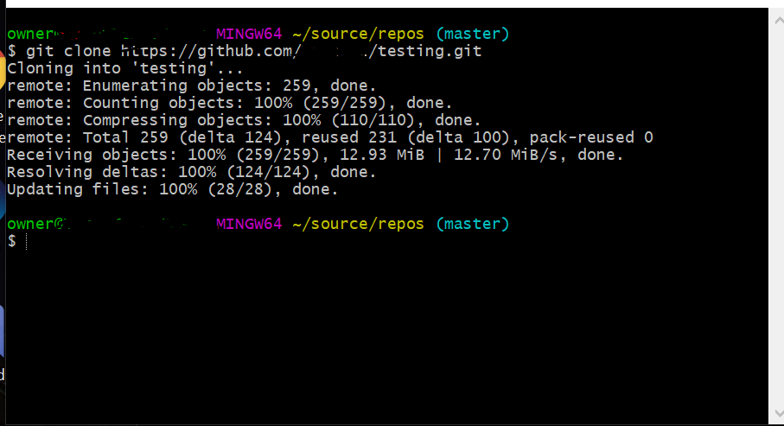

After that you can go into the repo ->.git -> hooks

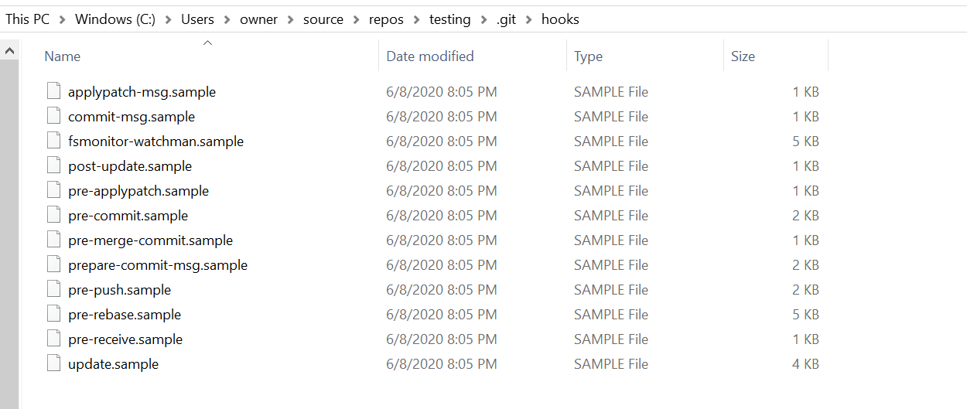

Right click in a blank area and do a new git bash here.

Type in the following commands:

‘ mv prepare-commit-msg.sample prepare-commit-msg’

‘ chmod +x prepare-commit-msg’

After that you need to copy and paste what I have written for the hook in my file deleting what is already in there, and whenever the program is committed it will make the file and list how many lines added and deleted.

**In Conclusion**

These steps can be similarly used to make your own git hooks, or change a git hook. You will just need to change the mv command to match the hook you are wanting to use.